**Lab - 06**

**Netsim**

**Program: MScIT Sem-2**

**Group ID : 28**

**Student Name Student ID**

Saif Saiyed 202212083

**4.3 Exercise**

Exercise 1: allocating IP addresses

1. Open new internetwork in Netsim.

2. Design topology as shown in figure 8 using drag and drop function on the icon of node and switch.

3. Change the ip address to ”192.168.10.80” and subnet mask ”255.255.255.0” of the wired node A. You may find the Interface1 ethernet property in the properties wired node, where you can edit the ip address and subnet mask.

4. Run the simulator for 10 second.

**4.3.1 Questions**

ex1: allocating IP addresses

**1. Write down the Ip address and subnet mask of both the node.**

ip address of wired node A = 192.168.10.0

subnet mask of wired node A = 250.250.250.0

ip address of wired node B = 11.1.0.0

subnet mask of wired node B = 250.250.0.0

**2. Write down the number of packet transmitted using simulation results.**

Number Of Packet Transmitted : 0

**3. How many packets have been received? Why?**

Number Of Packets Received: 0,

Reason : They Are Having IP Address (Not In Same Network)

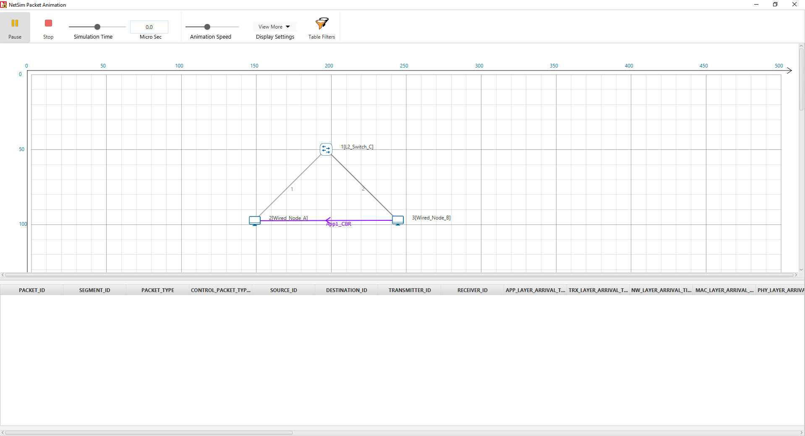

**4.4 Exercise 2: allocating IP addresses**

1. Edit the experiment of exercise 1.

2. Change the Ip address of wired node B to ”192.168.10.81” and subnet

mask ”255.255.255.0”.

3. Run the simulation for 10 second.

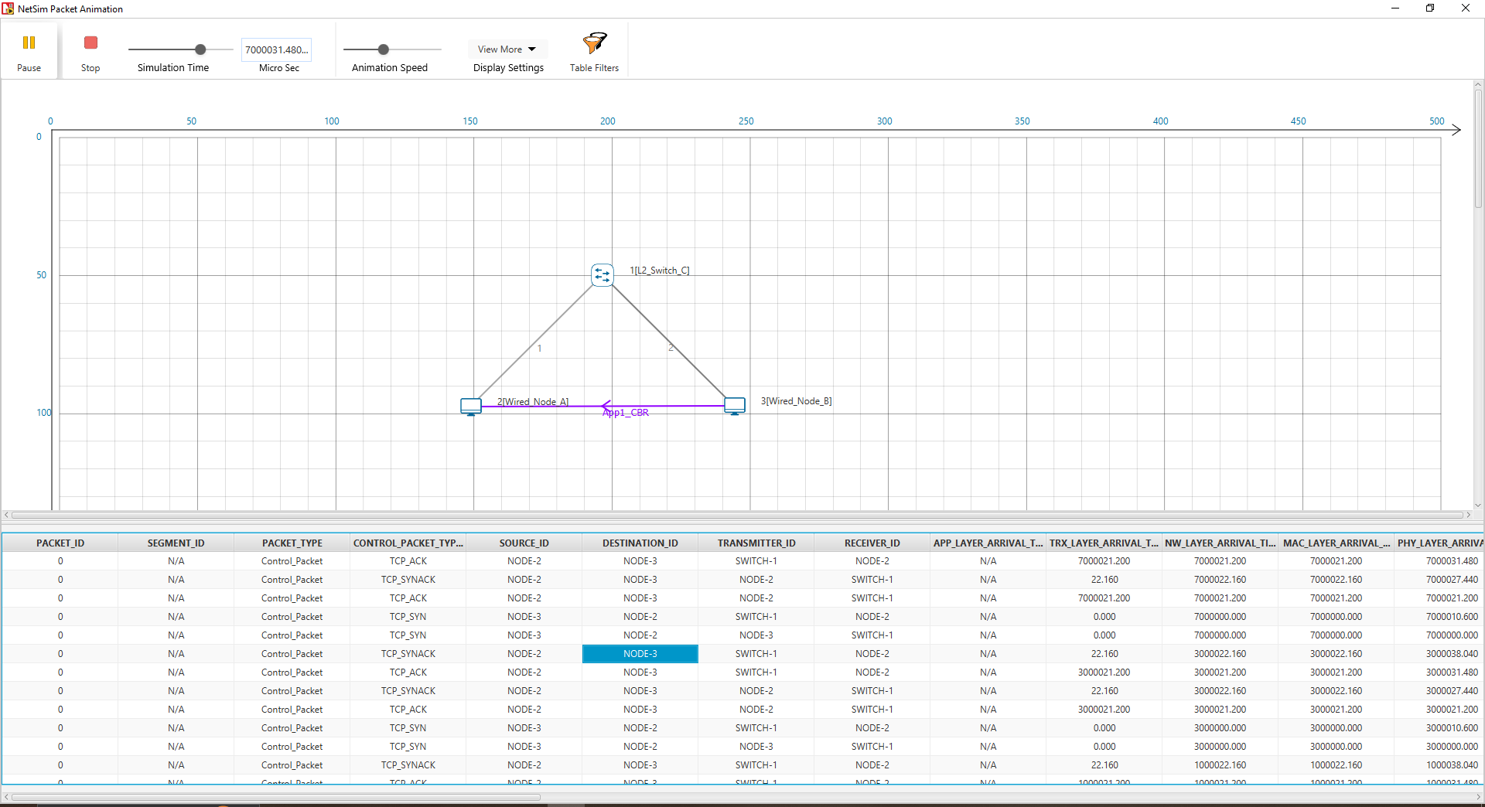

**4.4.1 Questions ex2: allocating IP addresses**

**1. How many packets have been received?**

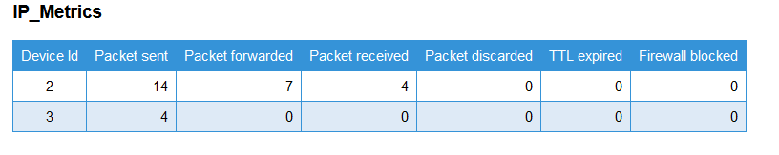

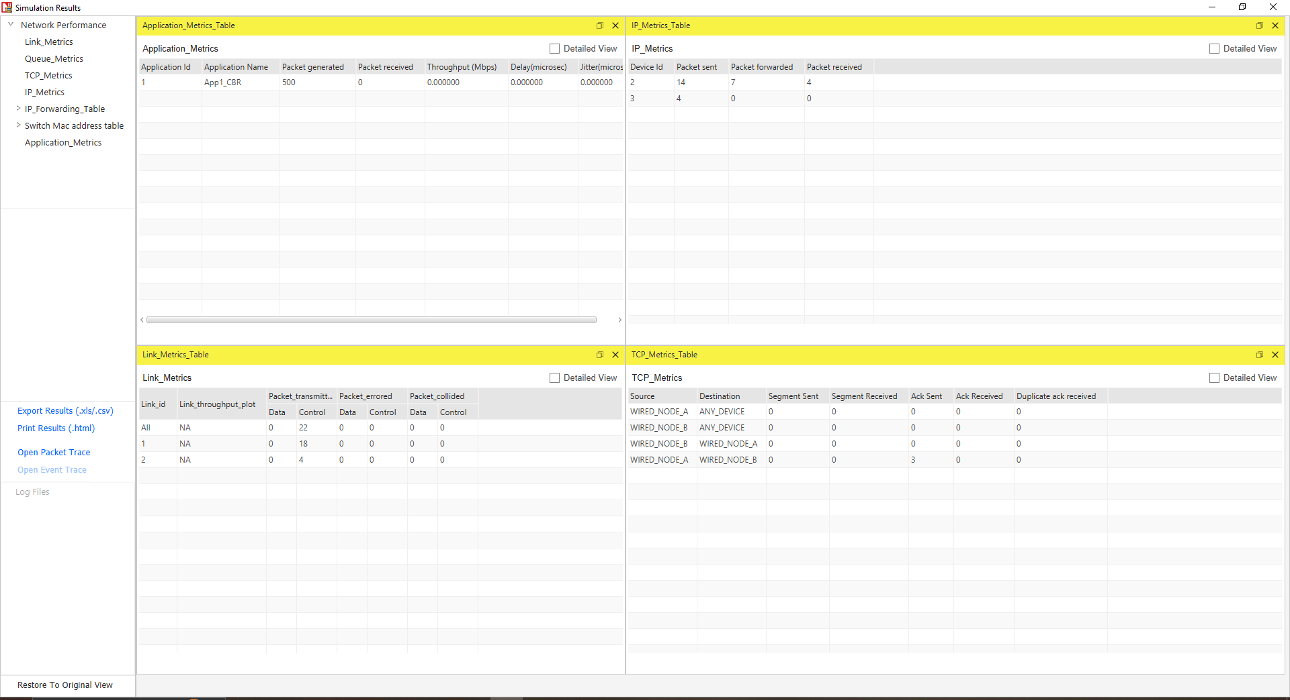

**2. What is the difference between the Exercise between 1 and 2?**

Because They Are On Same Network

**5.1 Exercise**

Exercise 1:Know your PC

1. Open the command prompt of your PC by writing cmd in the start menu.

2. write down the command ”ipconfig /all”

3. press enter.

**5.1.1 Questions**

**1. Search for the field of physical address and write down the values.**

Physical Address. . . . . . . . . : 1C-1B-0D-E1-92-C2

**2. How many physical addresses have you find? why ?**

The physical addresses listed above are accessible because the number of physical addresses reported by the command is determined by the number of network adapters in the system.

**3. Search for the field ip address and subnet mask and write down the value.**

IPv4 Address. . . . . . . . . . . : 192.168.31.95(Preferred)

Subnet Mask . . . . . . . . . . . : 255.255.255.0

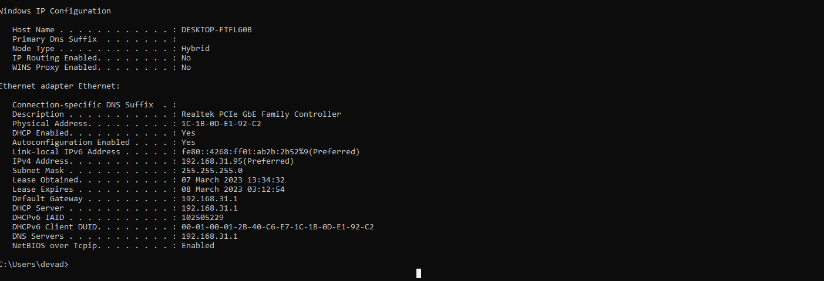

**5.2 Exercise**

**1. Write down the command on cmd ”route PRINT” Observe the results,**

**this command will give you the routing table of your own PC.**

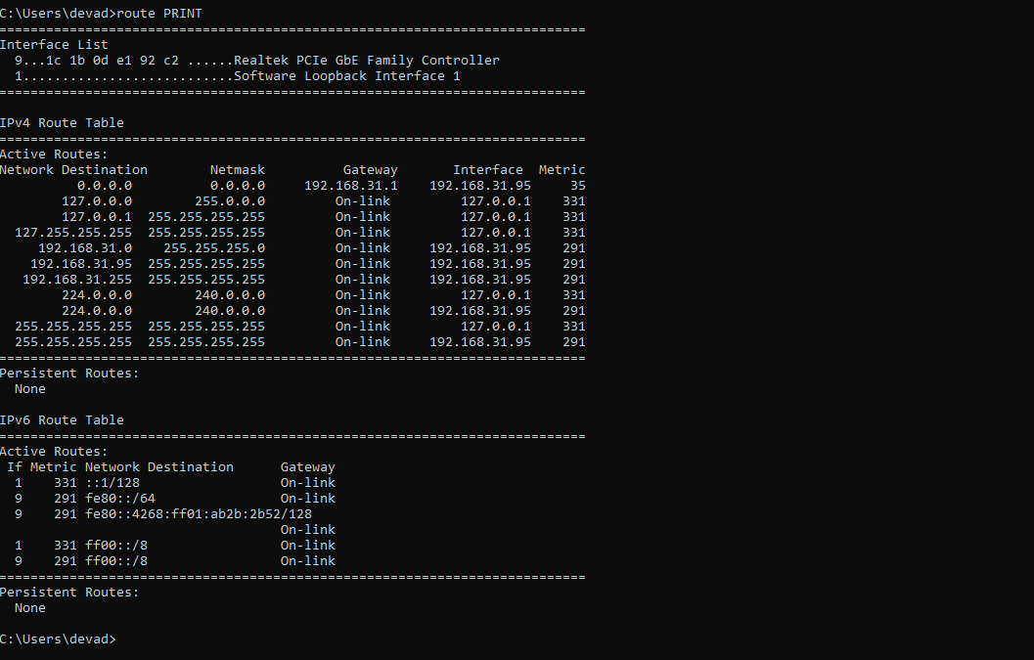

**2. Write down the command on cmd ”ping daiict.ac.in”, here you can see the**

**packets transmission between your PC and daiict network. write down the**

**packet transmitted, received and maximum,minimum and average time.**

Minimum = 15ms, Maximum = 15ms, Average = 15ms

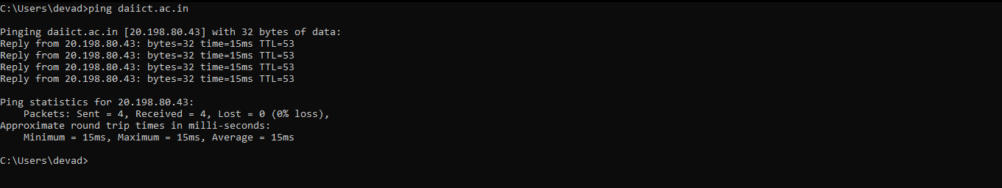

**3. Try the ping command with your friend’s ip adress. ”ping x.x.x.x” where**

**x.x.x.x would be the ip address of your friend. write down the packet**

**transmitted, received and maximum, minimum and average time.**

Minimum = 2ms, Maximum = 997ms, Average = 504ms

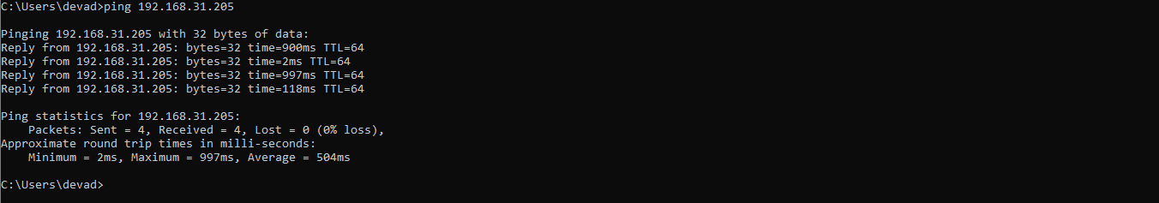

**4. Compare the result of last two operation. What is the difference between**

**two. Why there is a difference according to you.**

* The two pings have different values for minimum, maximum, and average.
* The first ping has a minimum of 15ms, a maximum of 15ms, and an average of 15ms. This indicates that the latency or delay in receiving a response from the server was consistently 15ms throughout the entire test.
* The second ping has a minimum of 2ms, a maximum of 997ms, and an average of 504ms. This indicates that the latency in receiving a response from the server varied greatly during the test, ranging from 2ms to 997ms, with an average of 504ms.

**5. Write ”tracert google.com” in cmd. Observe the results. Tracert command**

**gives the number of minimum hop between you and the destination.**

There are 8 hopes in my connection

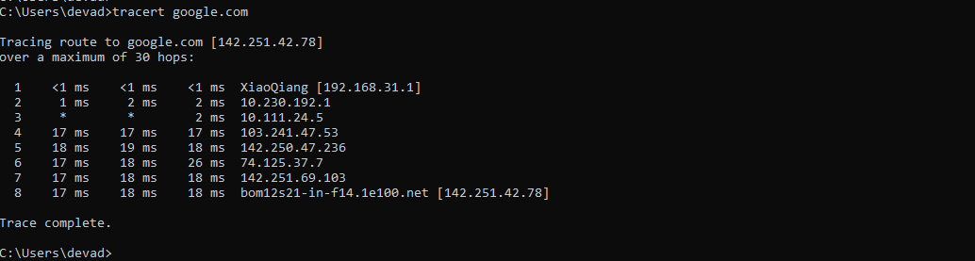

**6. Try the ”tracert” command with another website and write down the**

**results. For instance, 1) daiict.ac.in 2)amazon.in 3)facebook.com and ob-**

**serve the difference. Why there is difference according to you.**

1: daiict.ac.in

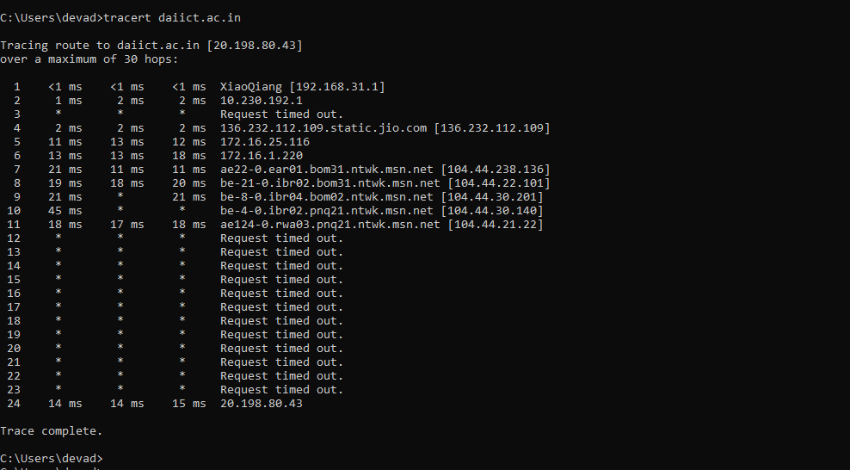

2:amazon.in

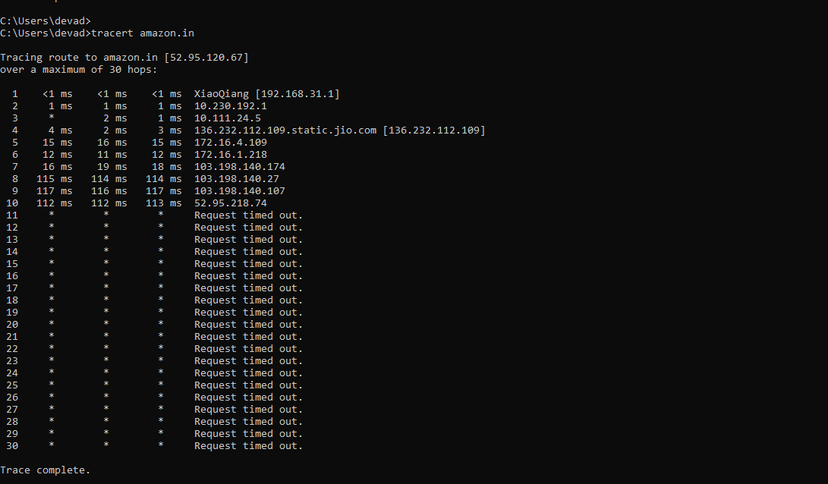

3:facebook.com

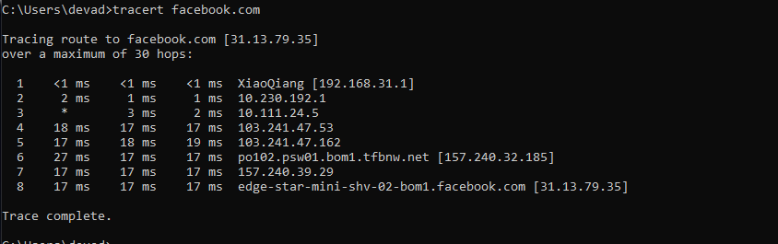

Overall, the "tracert" results can vary widely depending on the website being accessed, the location of the server, and the network conditions at the time of the test. It is important to take these factors into account when analyzing the results of a "tracert" test.

**6.2 Star topology:**

1. Devices:

* 10 wired nodes
* 1 L2 switch

2. Topology: Star topology(All the wired nodes connecte)

3. Implement 5 different applications between every disjoint pair of wired

nodes(i.e. 1-2,3-4,5-6,7-8,9-10) with following properties:

1. HD video: This is a video application which sends 30 frames per second and every frames contains 105 pixels. It uses normal distribution to generate bits per pixel with μ = 0.52 and σ= 0.23

2. You tube: This is a video application which sends 20 frames per second and every frames contains 104 pixels. It uses normal distribution to generate bits per pixel with μ = 0.52 and σ = 0.23

3. Gmail: This is an EMAIL application which sends and receives mail of 30000 bytes at every 2s.

4. Browsing: This is a HTTP application in which server sends 3 pages, each of size 25000 bytes at every 2 s.

5. Database: This is a database application in which a transaction of size 104 bytes are sent at every 105μ s.

6. Link properties: Set propagation delay=5ms

Results:

1. Find throughput of every application.

2. Find average throughput of video applications

3. Find average throughput of all the applications.

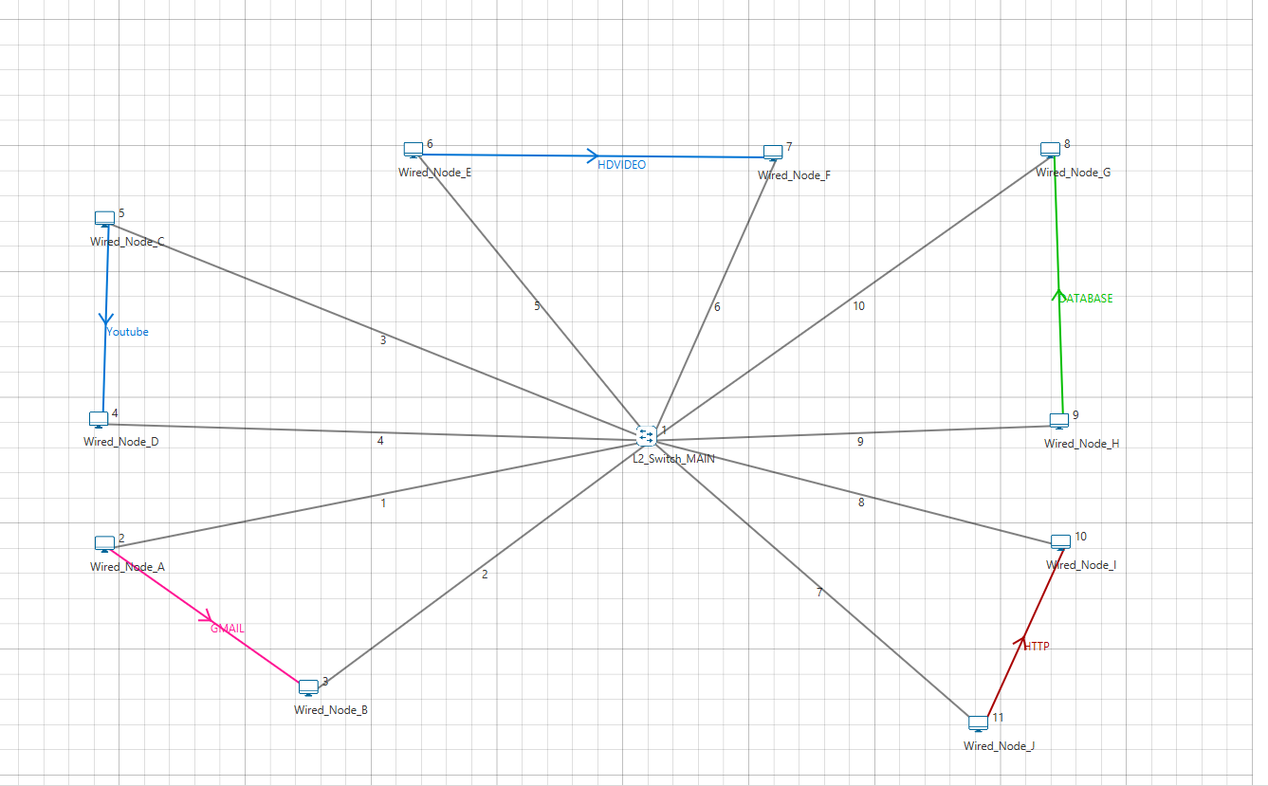

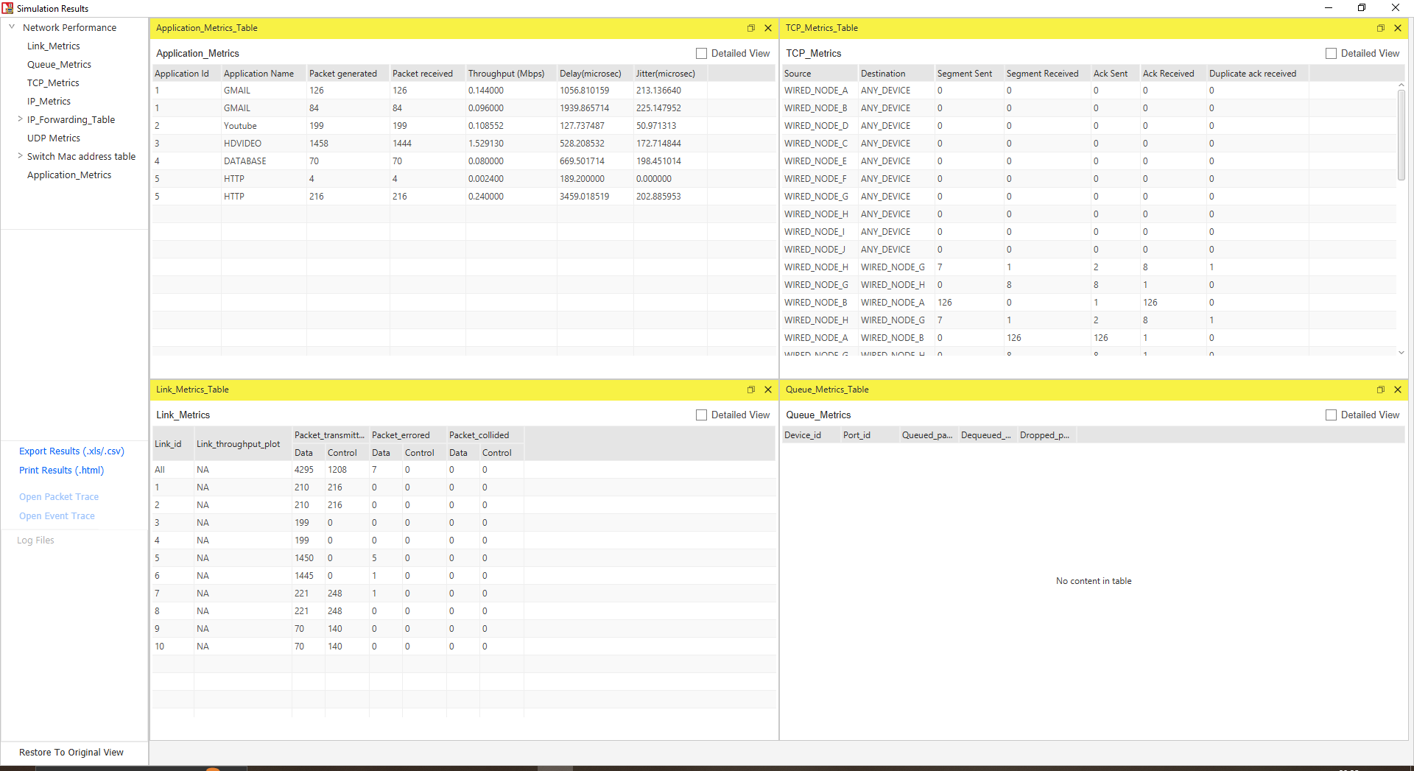

Results:

**1. Find throughput of every application.**

→ HDVideo - 1.529130 Mbps

→ Youtube - 0.108552 Mbps

→ Gmail - 0.240000 Mbps

→ Browsing - 0.2424 Mbps

→ Database - 0.080000 Mbps

**2. Find average throughput of video applications**

→ Average Throughput: 0.818841 Mbps

**3. Find average throughput of all the applications.**

→ Average Throughput: 0.4400164 Mbps